Vascular wilt (Fusarium oxysporum) Life cycle diagram:

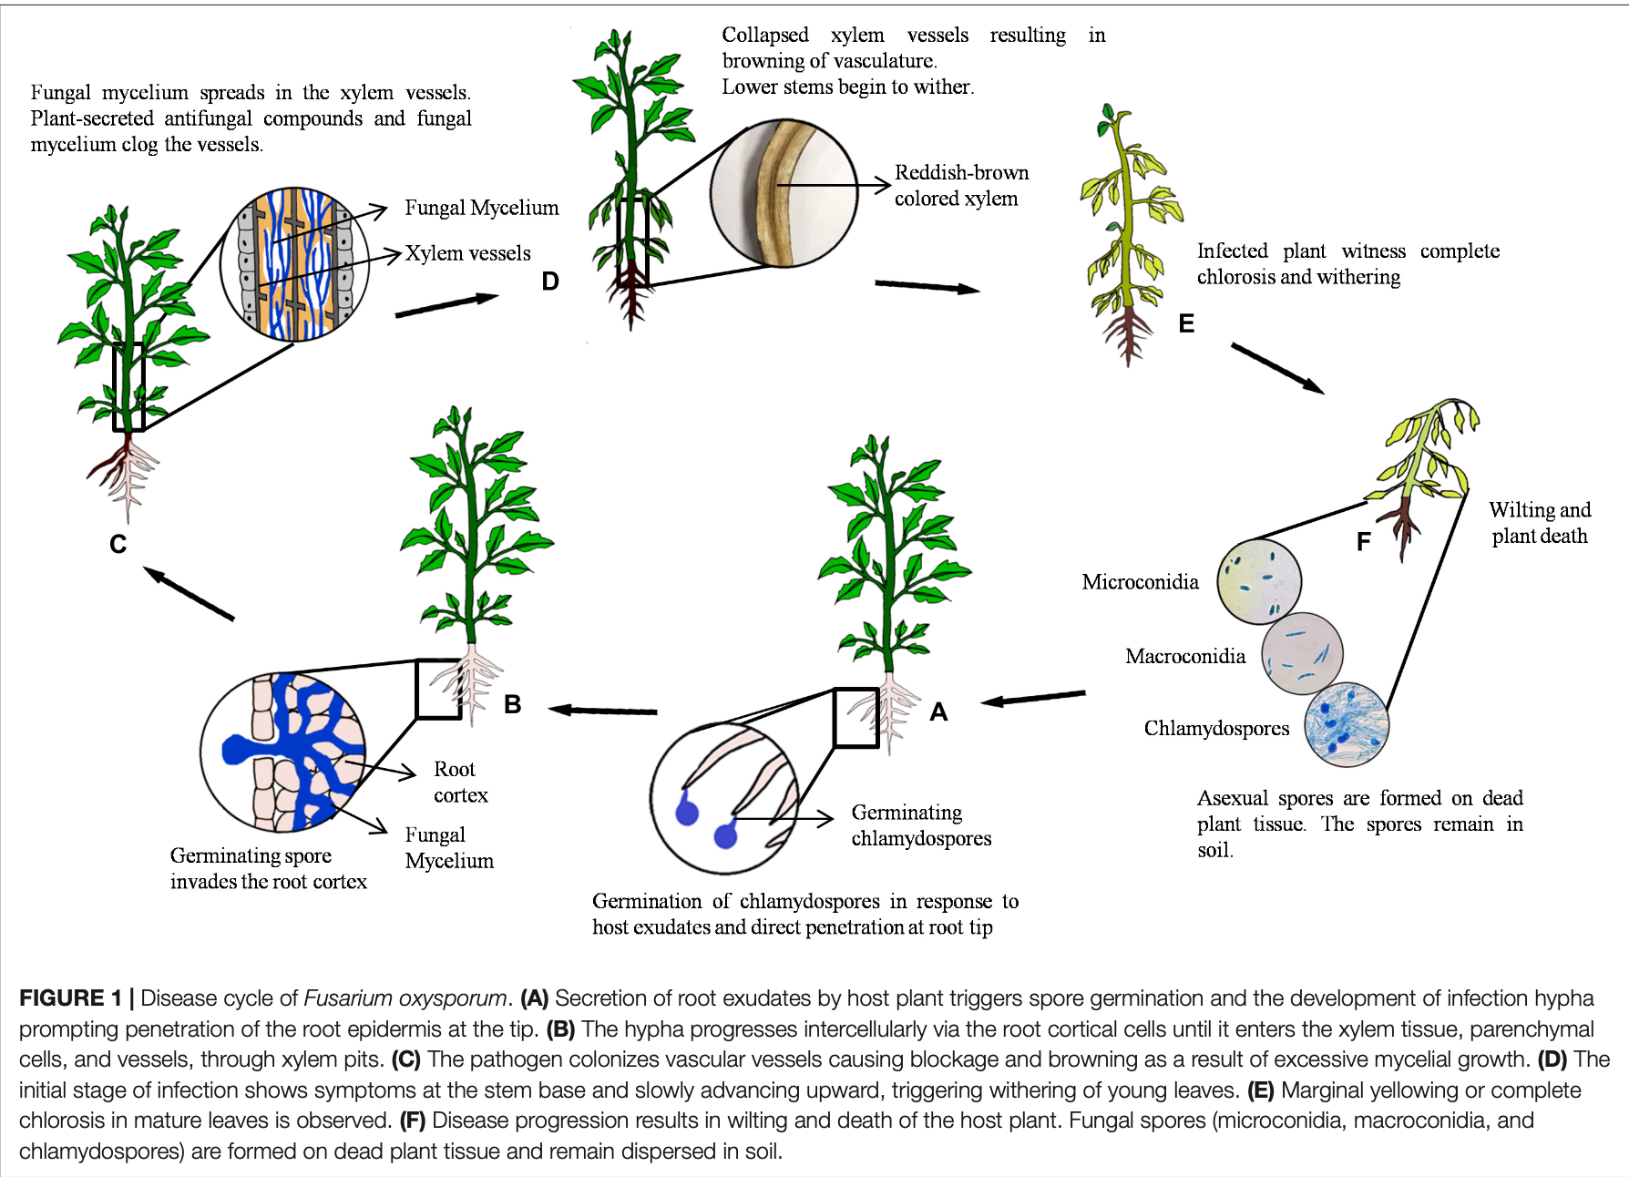Jangir et al 21
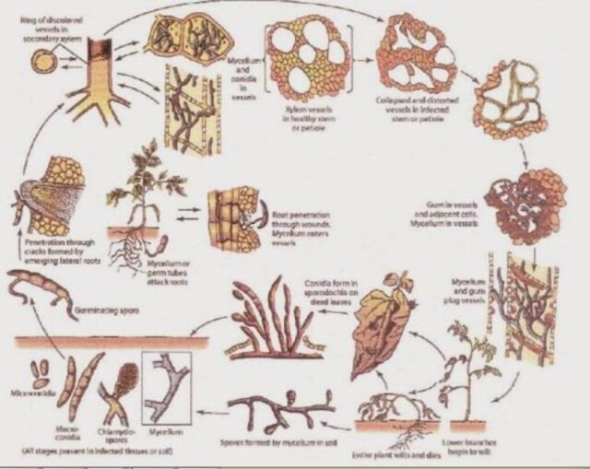
- Zulfadli et al 23

The life cycle of Fusarium oxysporum is as follows:
- Overwintering
- Fusarium oxysporum survives in the soil and on infected plant residues as chlamydospores, which are thick-walled mycelium cells.
- Germination
- When host roots grow near the chlamydospores, they germinate.
- Infection
- The fungus infects the plant through the root tips, wounds, or lateral roots.
- Growth
- The fungus grows through the cortex and into the xylem, where it produces microconidia.
- Spread
- The microconidia are transported through the sap stream and germinate where the flow stops.
- Clogging
- The microconidia and mycelia clog the vascular vessels, preventing the plant from absorbing and transporting nutrients.
- Wilting
- The plant transpires more than it can transport, the stomata close, the leaves wilt, and the plant dies.
- Sporulation
- After the plant dies, the fungus invades all tissues, sporulates, and continues to infect neighboring plants.
- Return to soil
- The chlamydospores are returned to the soil when the dead plant decays and can remain dormant for several years.
Structures:
- Chlamydospores
- Ascospores
- Conidiophores
- microconidia
- Mycelium growing in vascular tissue of plants, traveling through pit cells
- Mycelium penetrating root cortical cells
- Plant wilting
- Vascular tissue (xylem) infected with mycelium

